**OPS102 – Week 2 – File Systems - Sample Lab**

Student Name: Abcedi Ilacas

Student ID: 138180211

Please refer to File System Basics lecture slides for this lab

**Activity 1: File System Hierarchy**

Task 1: Login to matrix, and show a screenshot of your home directory listing all files and directories.

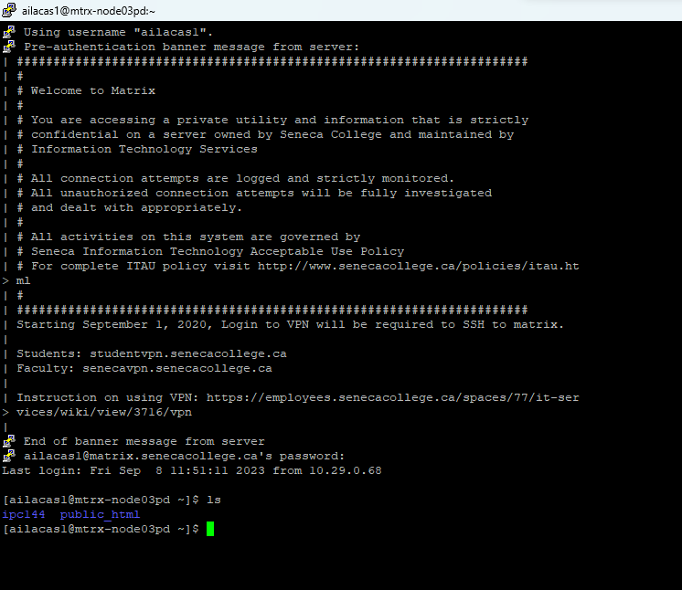  
  
Task 2: Repeat Task 1 for the / (root of the Linux) directory and show the screenshot here.



Task 3: Now login to your Windows account, open command prompt and repeat above two tasks and show screenshots here of your C:\Users\<your-username> directory

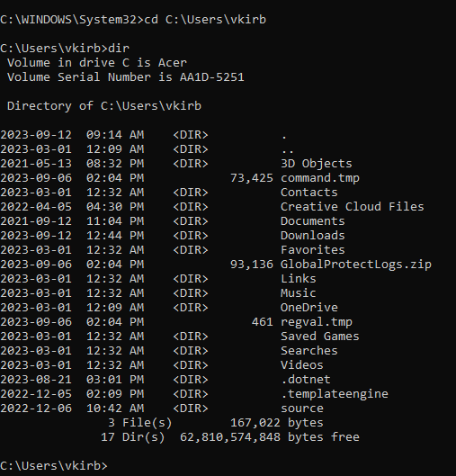

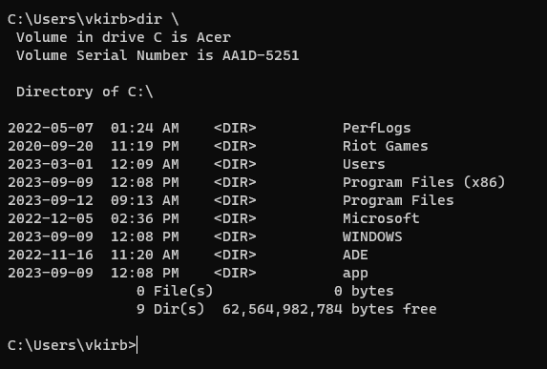

**Activity 2: Paths**

Consider following file hierarchy.

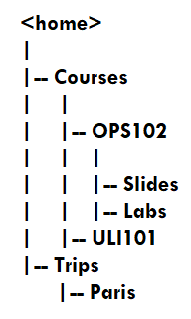

Task 1: List the absolute path of each folder shown in above image, for both Linux and Windows operating systems (You can consider this hierarchy in your home directory. Also note that absolute path starts from root directory (/) on Linux and (C:) on Windows) (you don’t need to use terminal or command prompt for these tasks, you can just type the paths):

Absolute Paths on Linux:

1. /home/ailacas1/Courses
2. /home/ailacas1/Courses/OPS102
3. /home/ailacas1/Courses/OPS102/Slides
4. /home/ailacas1/Courses/OPS102/Labs
5. /home/ailacas1/Courses/ULI101
6. /home/ailacas1/Trips
7. /home/ailacas1/Trips/Paris

Absolute Paths of Windows:

1. C:\Users\vkirb\Courses
2. C:\Users\vkirb\Courses\OPS102
3. C:\Users\vkirb\Courses\OPS102\Slides
4. C:\Users\vkirb\Courses\OPS102\Labs
5. C:\Users\vkirb\Courses\ULI101
6. C:\Users\vkirb\Trips
7. C:\Users\vkirb\Trips\Paris

Task 2: List relative-to-home paths for “Slides” and “Labs” folders on Linux

1. ~/Courses/OPS102/Slides
2. ~/Courses/OPS102/Labs

**Activity 3: Creating Directories**

Consider again the above folder hierarch:

  
(these are all directories, not files)

Task 1: On your matrix account use “ls” command in your home directory to show that above file hierarch does not exist:



Task 2: Use the “mkdir” command to create above hierarchy in your home directory, creating one directory at a time. After creating all the hierarchy take one screenshot to show all executed commands.

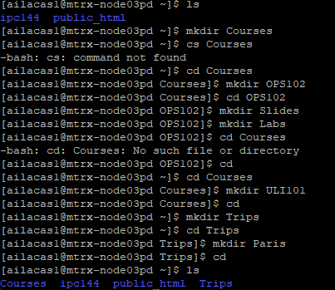

Task 3: Repeat above two tasks for Windows using command prompt and show the screenshots below.

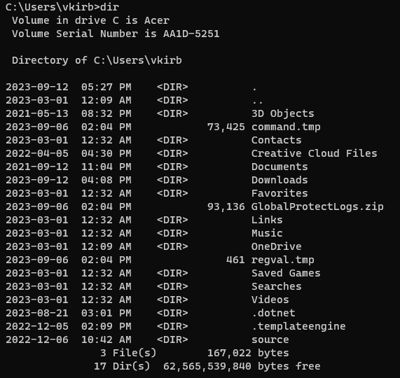

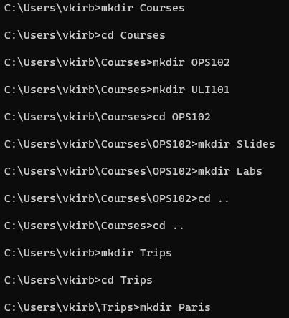

**Activity 4: File and Directory Operations**

Task 1: On your matrix account “cd” to “Courses” directory and execute “ls” command, then use touch command to create following files in this (“Courses”) directory:

Week1.txt

Week2.txt

Execute “ls” command again to show that these files have been created. Take a Screenshot of commands and add below

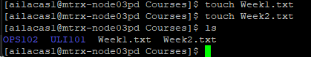

Task 2: Use “cp” command to copy above two new files to the “Slides” folder shown in above file hierarch in Activity 3, and take a screenshot:

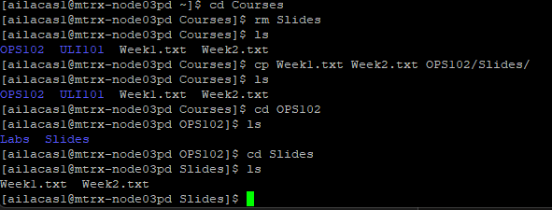

Task 3: Use “mv” command to move “Week1.txt” and “Week2.txt” files to “Labs” folder. (After executing this task you should have two copies of these files in “Slides” and “Labs” folders and no copy in “Courses” folder) show the screenshot of executed commands below.

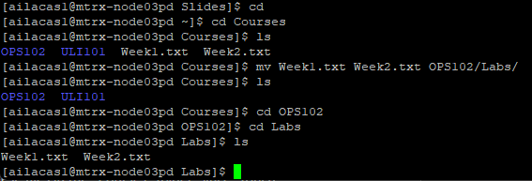

Task 4: Repeat above 3 tasks for Windows using command prompt and add all screenshots below (you can use any way of creating these files in the “Courses” folder, since “touch” command does not exist on Windows).

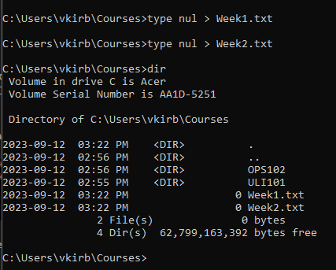

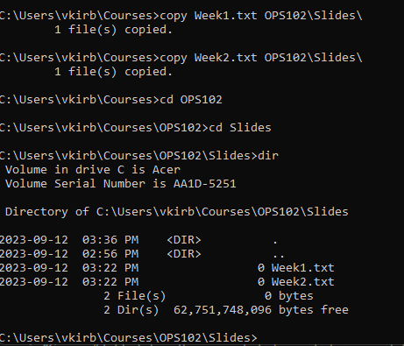

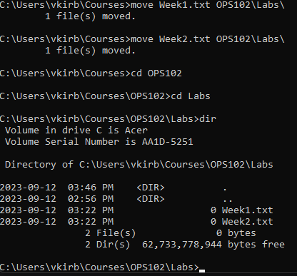

Task 5: Use “rm” command on Linux to delete the two files from both “Slides” and “Labs” folders and show the screenshots below.

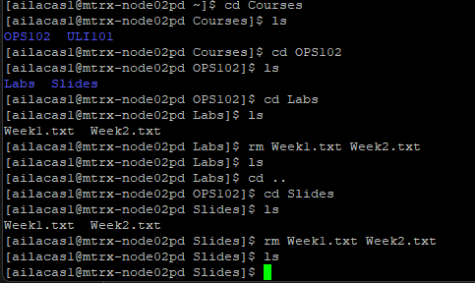

Task 6: Use “rmdir” command iteratively on Linux to delete the folder hierarchy created in Activity 3 and add screenshot below.

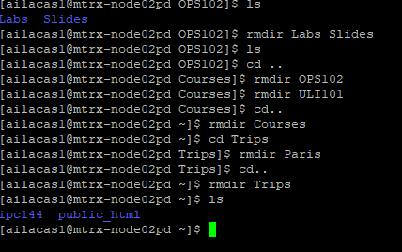

Task 7: Use “del” command on Winodws to delete the two files from both “Slides” and “Labs” folders and show the screenshots below.

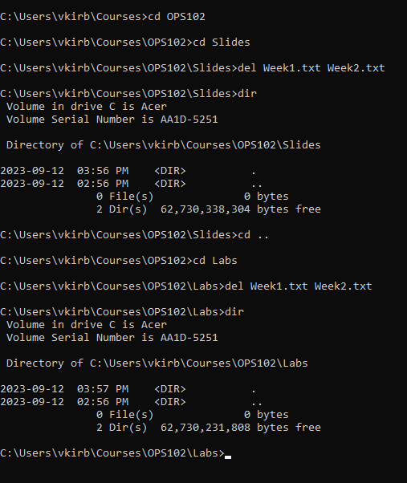

Task 8: Use “rd” command iteratively on Windows to delete the folder hierarchy created in Activity 3 and add screenshot below.

